

CC-215-L: Database Systems Lab
Faculty of Computing & Information Technology

BS(CS&IT) Morning - Fall 2023
LAB – 07
The objective of this lab is to:
- Revise Previous Content
- Practice DDL
Course & Lab Instructor: Dr. Asif Sohail
LAB TIMING : 60 MINS
TOTAL MARKS : 30
Task 01: [10 Marks]
- Create the following Tables.
STUDENT
CREATE TABLE STUDENT
(ROLLNO CHAR(10) PRIMARY KEY,
FIRSTNAME VARCHAR2(20) NOT NULL,
LASTNAME VARCHAR2(20) NOT NULL,
CNIC CHAR(30) UNIQUE,
GENDER CHAR(1) CONSTRAINT C_GENDER CHECK(GENDER IN ('M','F')),
PHONENO CHAR(11) NOT NULL);

desc student

Col Name | Data Type | Size | Constraints
RollNo | CHAR | 10 | PrimaryKey
FirstName | VARCHAR2 | 20 | Non-Nullable
LastName | VARCHAR2 | 20 | Non-Nullable
CNIC | CHAR | 13 | Unique
Gender | CHAR |  | M or F
PhoneNo | CHAR | 11 | Not Null
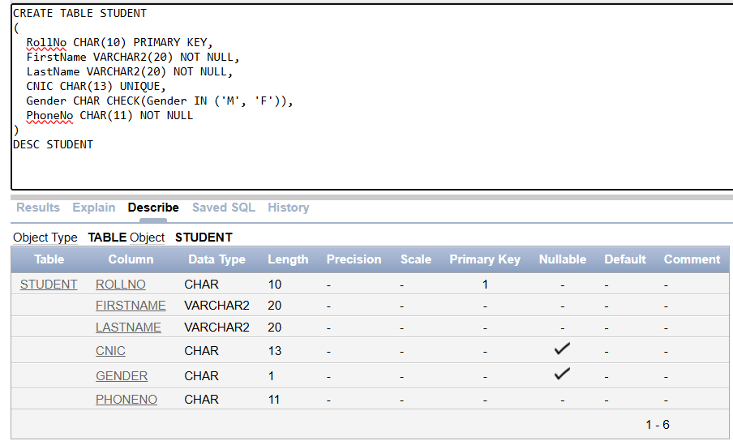

INSTRUCTOR
CREATE TABLE INSTRUCTOR
(REGNO CHAR(10) PRIMARY KEY,
FIRSTNAME VARCHAR2(20) NOT NULL,
QUALIFICATION VARCHAR2(300) NOT NULL,
JOINING DATE DEFAULT SYSDATE);

Col Name | Data Type | Size | Constraints
RegNo | CHAR | 10 | PrimaryKey
FirstName | VARCHAR2 | 20 | Non-Nullable
Qualification | VARCHAR2 | 300 | Non-Nullable
JoiningDate | Date |  | Current Date by Default
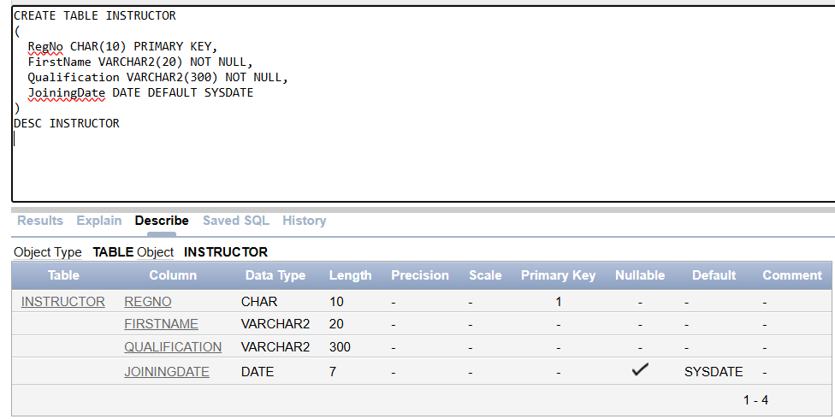
COURSE
CREATE TABLE COURSE
(COURSECODE CHAR(10) PRIMARY KEY,
COURSETITLE VARCHAR2(250) NOT NULL,
INSTRUCTORID CHAR(10) CONSTRAINT FK_INSTRUCTORID REFERENCES INSTRUCTOR(REGNO),
PREREQUISITE CHAR(10) CONSTRAINT FK_PREREQUISITE REFERENCES COURSE(COURSECODE));

Col Name | Data Type | Size | Constraints
CourseCode | CHAR | 10 | PrimaryKey
CourseTitle | VARCHAR2 | 250 | Non-Nullable
InstructorID | CHAR | 10 | Points to RegNo in INSTRUCTOR
PreRequisite | CHAR | 10 | Points to CourseCode
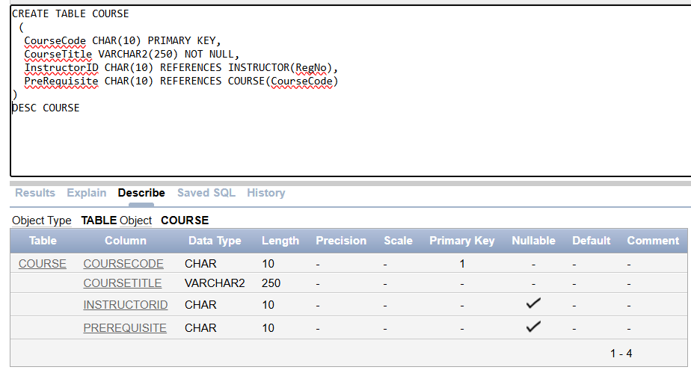
ENROLLMENT
CREATE TABLE ENROLLMENT
(STUDENTID CHAR(10) CONSTRAINT FK_STUDENTID REFERENCES STUDENT(ROLLNO),
COURSECODE CHAR(10) CONSTRAINT FK_COURSECODE REFERENCES COURSE,
ENROLLMENTDATE DATE DEFAULT SYSDATE,
GRADE CHAR(1) DEFAULT 'F',
CONSTRAINT PK_ENROLLMENT PRIMARY KEY(STUDENTID, COURSECODE),
CONSTRAINT C_GRADE CHECK(GRADE IN ('A','B','C','D','F')) );

Col Name | Data Type | Size | Constraints
StudentID | CHAR | 10 | PrimaryKey,  Points to RollNo in Student
CourseCode | CHAR | 10 | PrimaryKey,  Points to CourseCode in Course
EnrollmentDate | DATE |  | Current Date by Default
GRADE | CHAR |  | A,B,C,D or F, F by Default
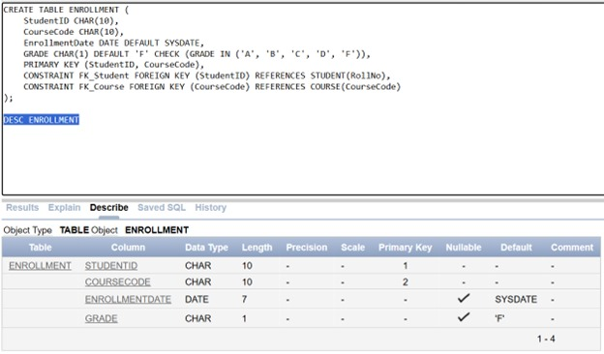
ATTENDANCE
CREATE TABLE ATTENDANCE
(STUDENTID CHAR(10) CONSTRAINT FK_ASTUDENTID REFERENCES STUDENT(ROLLNO),
COURSECODE CHAR(10) CONSTRAINT FK_ACOURSECODE REFERENCES COURSE,
ATTENDANCEDATE DATE DEFAULT SYSDATE,
STATUS CHAR(1) DEFAULT 'A',
CONSTRAINT PK_ATTENDANCE PRIMARY KEY(STUDENTID, COURSECODE, ATTENDANCEDATE),
CONSTRAINT C_STATUS CHECK(STATUS IN ('A','P')) );

Col Name | Data Type | Size | Constraints
StudentID | CHAR | 10 | PrimaryKey, Points to RollNo in Student
CourseCode | CHAR | 10 | PrimaryKey,  Points to CourseCode in Course
AttendanceDate | DATE |  | PrimaryKey,  Current Date by Default
Status | CHAR |  | P or A, A by Default

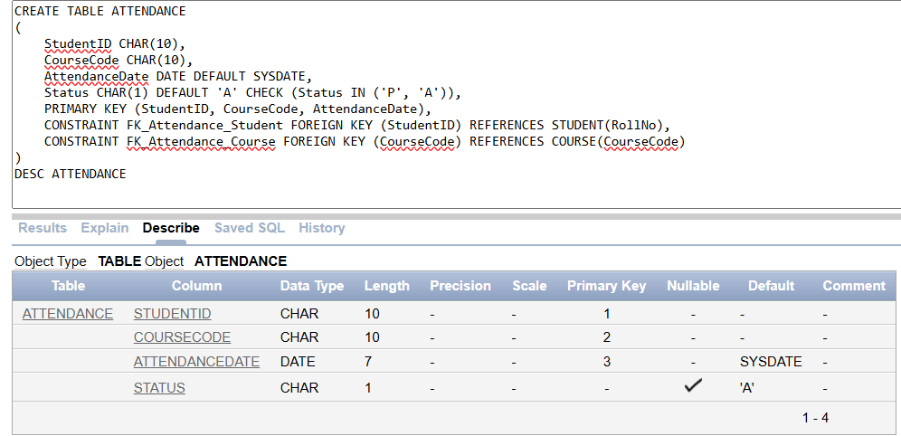
Task 02: [10 Marks]
- Add two new columns in INSTRUCTOR and STUDENT table. Types of both columns will be VARCHAR
  - PASSWORD Length not more than 20 characters
  - EMAIL 23 Characters
NOTE: The EMAIL fields in STUDENT table and INSTRUCTOR table will be rollno@pucit.edu.pk and regno@pucit.edu.pk respectively.

ALTER TABLE student
ADD (PASSWORD VARCHAR2(30))
ADD(EMAIL VARCHAR2 (23) default ' rollno@pucit.edu.pk');

ALTER TABLE INSTRUCTOR
ADD (PASSWORD VARCHAR2(30))
ADD(EMAIL VARCHAR2 (23) default ' regno@pucit.edu.pk');
- Rename the column “PASSWORD” in the STUDENTS table as “CREDENTIALS”
ALTER TABLE STUDENT
RENAME COLUMN PASSWORD TO CREDENTIALS
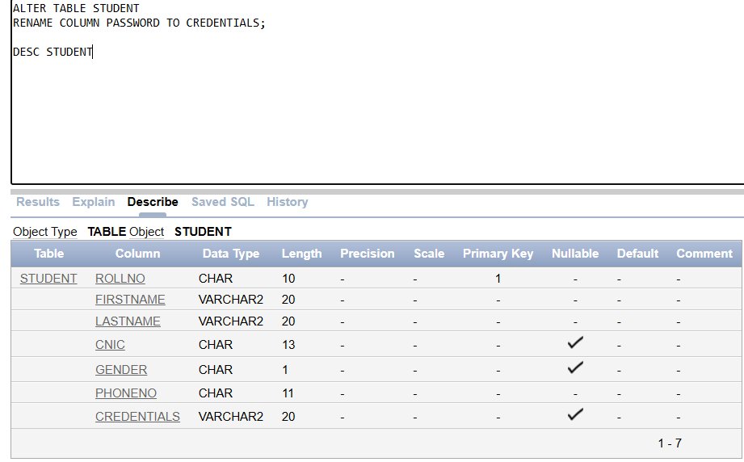
- Add a contrain to “PHONENUMBER” in “STUDENTS” that ensures the uniqueness of phone_number for each student. Name that constraint as “UQ_PN”
ALTER TABLE student
ADD CONSTRAINT UQ_PN UNIQUE(PHONENO);
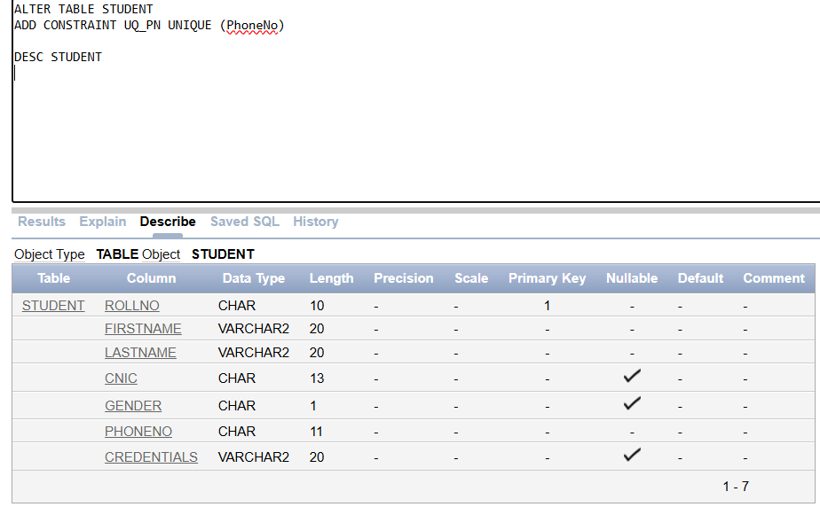
- Change the length of Password in INSTRUCTOR table to a limit of 30 characters
ALTER TABLE INSTRUCTOR
MODIFY PASSWORD VARCHAR2(30);
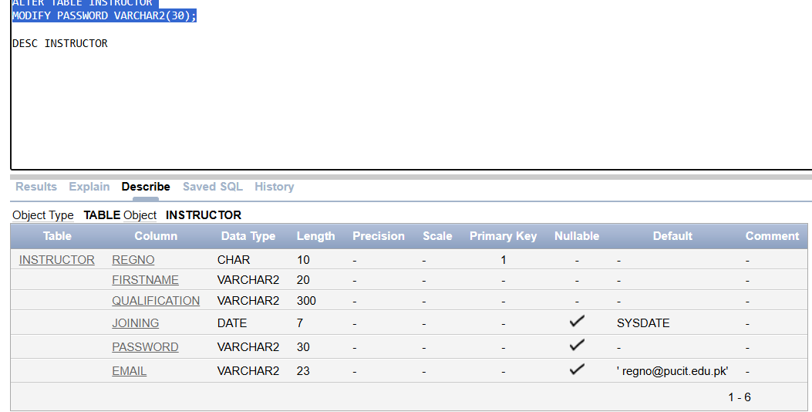
- Remove the Default Value constraint from “JOINING DATE” in INSTRUCTOR table
ALTER TABLE INSTRUCTOR
MODIFY JOINING DEFAULT NULL;
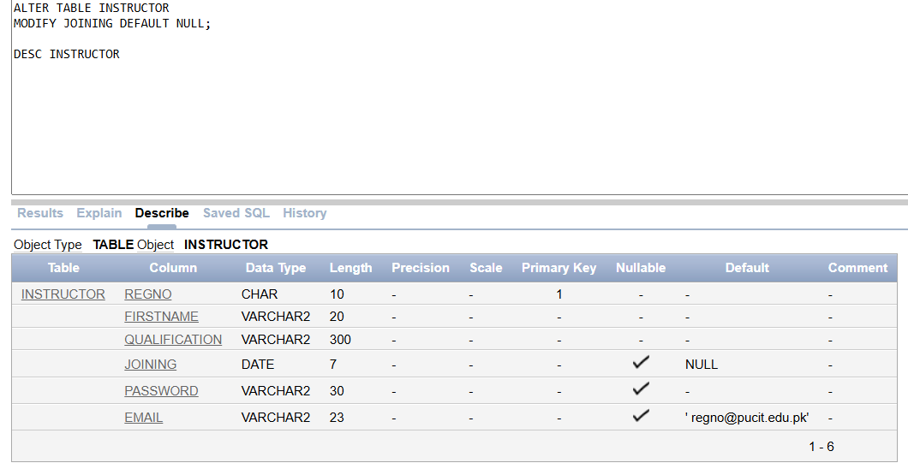
- Disable the Foreign Key constraint on “Course Code” in ENROLLMENT table
ALTER TABLE ENROLLMENT
DISABLE CONSTRAINT FK_COURSECODE;
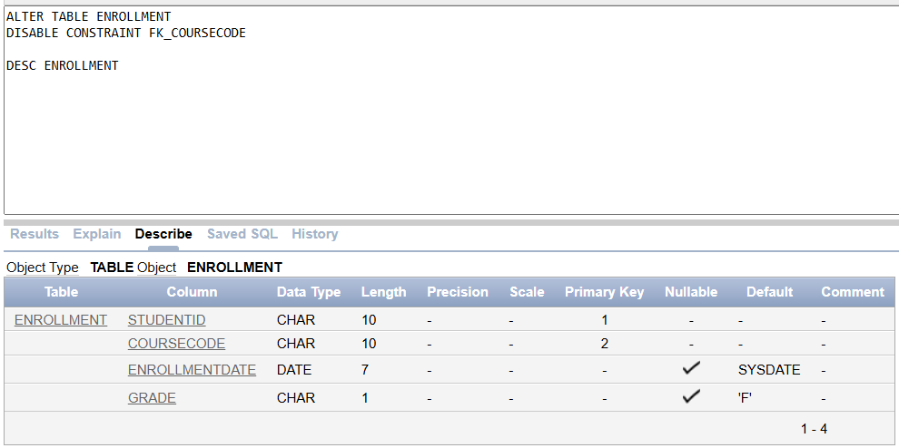
- Enable the constraint

- Write an SQL query to Display all the constraints on STUDENT table

ALTER TABLE ENROLLMENT
DISABLE CONSTRAINT FK_COURSECODE;
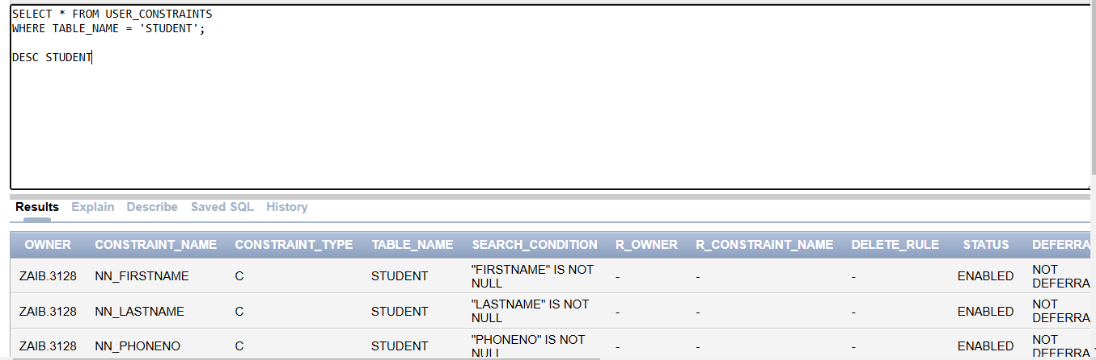
- Delete the Foreign Key Constraint on “CourseCode” in enrollment table
ALTER TABLE ENROLLMENT
DROP CONSTRAINT FK_COURSECODE;
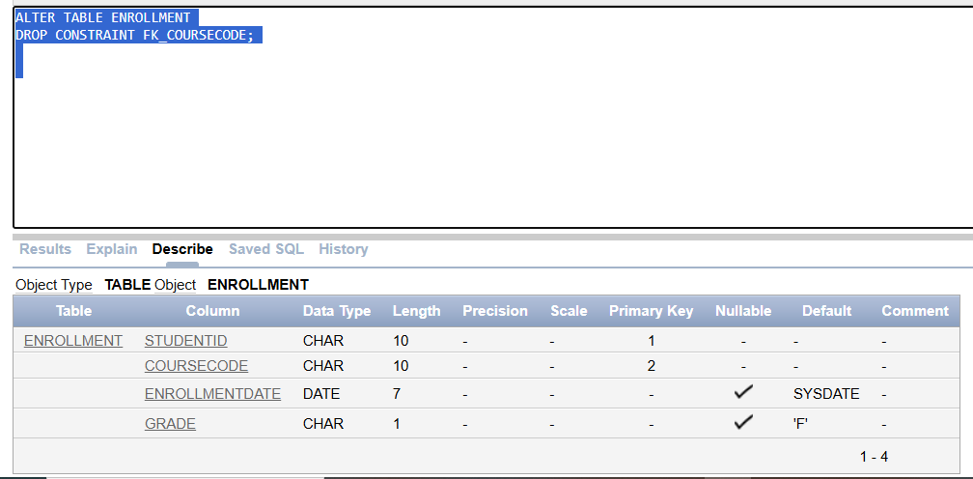
- Add the Foreign Key constraint “CourseCode” such as if the parent value is deleted, then the child table must have values set to NULL

Task 03: [10 Marks]
- Write a query to find departments with greater or equal to average number of Job titles.
SELECT DEPTNO,COUNT(DISTINCT JOB)
FROM EMP
GROUP BY DEPTNO
HAVING COUNT(DISTINCT JOB) >= (SELECT AVG(COUNT(DISTINCT JOB)) FROM EMP GROUP BY DEPTNO);
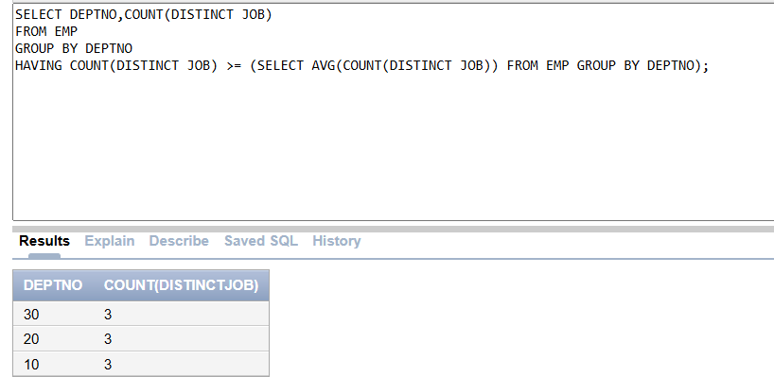
- Write a query to find employees who joined last in their departments.
SELECT ENAME,HIREDATE,DEPTNO
FROM EMP O
WHERE HIREDATE = (SELECT MAX(HIREDATE) FROM EMP WHERE DEPTNO = O.DEPTNO);
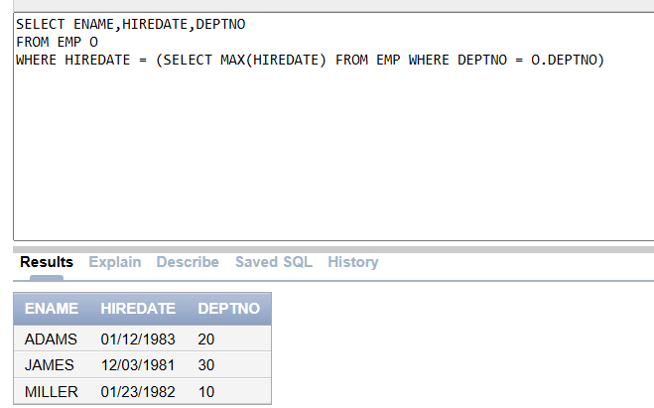
- Write a query to find employees earning more than any manager.
SELECT *
FROM EMP
WHERE SAL > ANY(SELECT SAL FROM EMP WHERE JOB ='MANAGER');
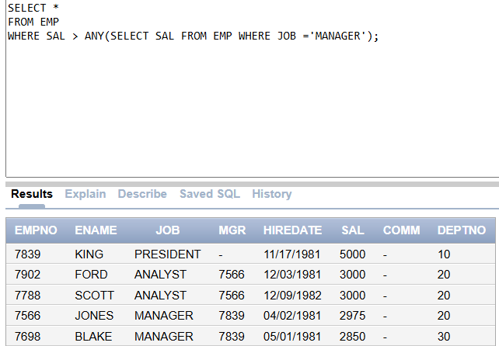
- Write a query to find top three highest earning job titles in each department.
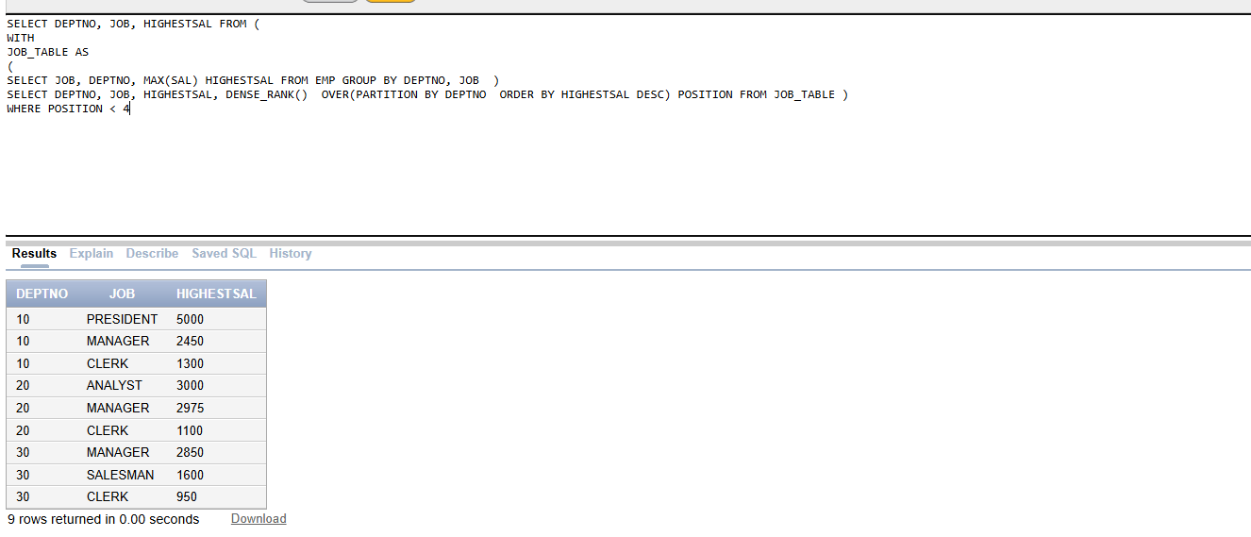
- Write a query to find employees whose salary matches the highest in another department.
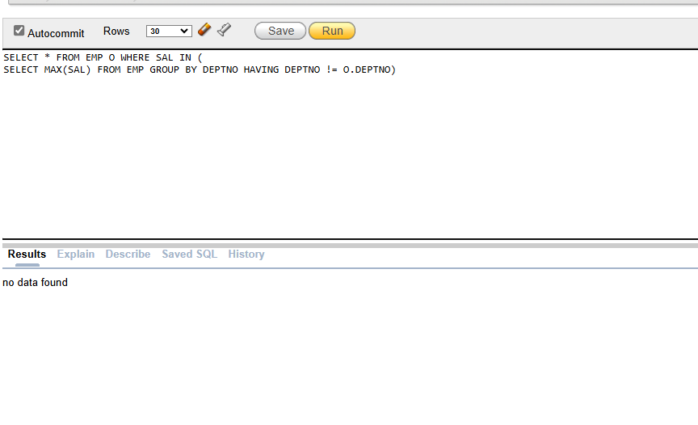
Task 04: Viva [5 Marks]

